GOVERNMENT ARTS AND SCIENCE COLLEGE

SRIVILLIPUTHUR

1.INTRODUCTION:

The 2019 Lok Sabha election in India was a watershed moment in the country's political landscape, witnessing the participation of a multitude of candidates from various political parties. In this comprehensive study, we delve into the intricacies of this pivotal election, offering a quantitative analysis of the political juggernauts that shaped the electoral landscape. Through a rigorous examination of candidate profiles, campaign strategies, and electoral outcomes, this research aims to shed light on the multifaceted dynamics of the 2019 Lok Sabha election. By employing data-driven approaches, we uncover the trends, strengths, and weaknesses of political candidates and parties, providing valuable insights into the state of Indian democracy during this critical juncture. Join us on this journey through the numerical labyrinth of Indian politics as we unravel the factors that propelled some candidates to victory while others faced defeat in the grand spectacle of the 2019 Lok Sabha election.

1.1.OVERVIEW:

1. **Election of Significance**: The 2019 Lok Sabha election was one of the largest democratic exercises in the world, involving over 900 million eligible voters and 543 constituencies. It was a critical juncture for Indian politics and democracy.
2. **Quantitative Approach**: This study employs a quantitative methodology, relying on data-driven analysis to delve into the intricacies of the election. By using statistical tools and techniques, the research aims to uncover patterns, trends, and insights that may have influenced the election's outcomes.
3. **Candidate Profiles**: One of the central focuses of the analysis is the candidates themselves. We examine the background, qualifications, and previous political experience of candidates who contested the 2019 election. This information is critical for understanding the caliber and diversity of individuals participating in the election.
4. **Campaign Strategies**: The study investigates the campaign strategies adopted by various candidates and political parties. It analyzes the allocation of resources, social media engagement, rallies, and other campaign methods employed to gain voter support.
5. **Electoral Outcomes**: A key objective of this research is to understand why some candidates were successful while others faced defeat. The study delves into the electoral outcomes, examining the factors that contributed to the victories and losses, and the impact on the overall composition of the Lok Sabha.
6. **Insights into Indian Democracy**: By shedding light on the dynamics of the 2019 Lok Sabha election, this study provides valuable insights into the state of Indian democracy. It offers a snapshot of the political landscape, the strengths and weaknesses of different candidates and parties, and the factors that drove the election's results.

"Political Juggernauts: A Quantitative Analysis of Candidates in the 2019 Lok Sabha Election" offers a comprehensive, data-driven exploration of a pivotal moment in Indian politics, ultimately contributing to a deeper understanding of the world's largest democracy and the intricacies of electoral politics in India.

1.2.PURPOSE:

1. **Understanding Electoral Dynamics**: The primary purpose of this analysis is to gain a deeper understanding of the electoral dynamics at play during the 2019 Lok Sabha election. By using quantitative methods, the study seeks to uncover the underlying factors that influenced candidate performance, party victories, and voter behavior.
2. **Candidate Profiling**: This research aims to profile and assess the qualifications, backgrounds, and political experience of candidates who contested the election. This information is crucial for evaluating the caliber and diversity of individuals participating in Indian politics.
3. **Campaign Strategy Assessment**: The study intends to assess the effectiveness of various campaign strategies used by candidates and political parties. By analyzing resource allocation, social media engagement, and other campaign tactics, it seeks to identify what worked and what did not.
4. **Determining Electoral Outcomes**: One of the central objectives is to determine why certain candidates emerged victorious while others faced defeat. This involves an examination of the factors contributing to electoral outcomes, helping to paint a clearer picture of what influences Indian voters.
5. **Contributing to Political Science**: By employing quantitative research methods in the context of a significant democratic event, the study contributes to the field of political science. It provides insights and data that can be used by scholars, policymakers, and political analysts to deepen their understanding of the Indian political landscape.
6. **Strengthening Democracy**: Ultimately, the research aims to contribute to the strengthening of Indian democracy by shedding light on the electoral processes and factors at work in the 2019 Lok Sabha election. This information can inform electoral reforms and political strategies to make democracy more vibrant and responsive to the needs of the Indian populace.
7. **Informing the Public**: The findings from this analysis have the potential to inform and educate the public about the complexities of Indian democracy. By presenting data-driven insights, the study can help citizens make informed decisions and engage more effectively in the political process.

In summary, "Political Juggernauts: A Quantitative Analysis of Candidates in the 2019 Lok Sabha Election" serves as a valuable research initiative with the overarching goal of providing a deeper and data-driven understanding of the critical 2019 Lok Sabha election in India.

2.PROBLEM STATEMENT AND DESIGN THINKING

**Problem Statement:** The 2019 Lok Sabha election in India was a pivotal moment in the country's political landscape. This election witnessed a multitude of candidates from various political parties, each vying for a seat in the Lok Sabha. However, there is a need to understand the electoral dynamics, campaign strategies, and the factors that led to the electoral outcomes to gain a deeper insight into the functioning of Indian democracy. The problem statement for this study is to determine the key factors influencing candidate success, electoral outcomes, and the impact on Indian democracy during the 2019 Lok Sabha election.

**Research Design:**

1. **Data Collection:**
   * Collect comprehensive data on candidates who contested the 2019 Lok Sabha election, including their demographic information, political affiliations, and campaign strategies.
   * Acquire election results data at the constituency level, detailing the winners, margin of victory, and party-wise performance.
2. **Data Analysis:**
   * Profile candidate backgrounds, political experience, and qualifications using quantitative and qualitative analysis.
   * Employ statistical methods to identify correlations and patterns in the data, including candidate success factors and the impact of campaign strategies.
3. **Campaign Strategy Assessment:**
   * Analyze campaign strategies used by candidates and political parties, including resource allocation, social media engagement, rallies, and advertisements.
   * Assess the effectiveness of various campaign tactics in terms of voter engagement and turnout.
4. **Electoral Outcome Analysis:**
   * Investigate the electoral outcomes, understanding why some candidates were successful while others faced defeat.
   * Examine factors such as demographic composition, regional differences, and incumbency effects that influenced the results.
5. **Data Visualization:**
   * Present the findings using data visualization techniques, including graphs, charts, and maps, to make the analysis more accessible to a broader audience.
6. **Contribution to Political Science:**
   * Provide insights into Indian electoral politics, offering recommendations for electoral reforms and policy changes.
   * Contribute to the field of political science by sharing the findings with the academic community through research publications and conferences.
7. **Policy Implications:**
   * Suggest policy implications and recommendations to strengthen Indian democracy, based on the research findings.
   * Communicate these findings to policymakers and relevant stakeholders.
8. **Dissemination:**
   * Publish the research in academic journals and present the findings at conferences to engage with the academic and policy communities.
   * Develop public-facing reports and infographics to inform the general public about the insights gained from the analysis.

This research design outlines the methodology, data collection, and analysis techniques to address the problem statement and provide a comprehensive analysis of the 2019 Lok Sabha election in India.

2.1.EMPATHY MAP: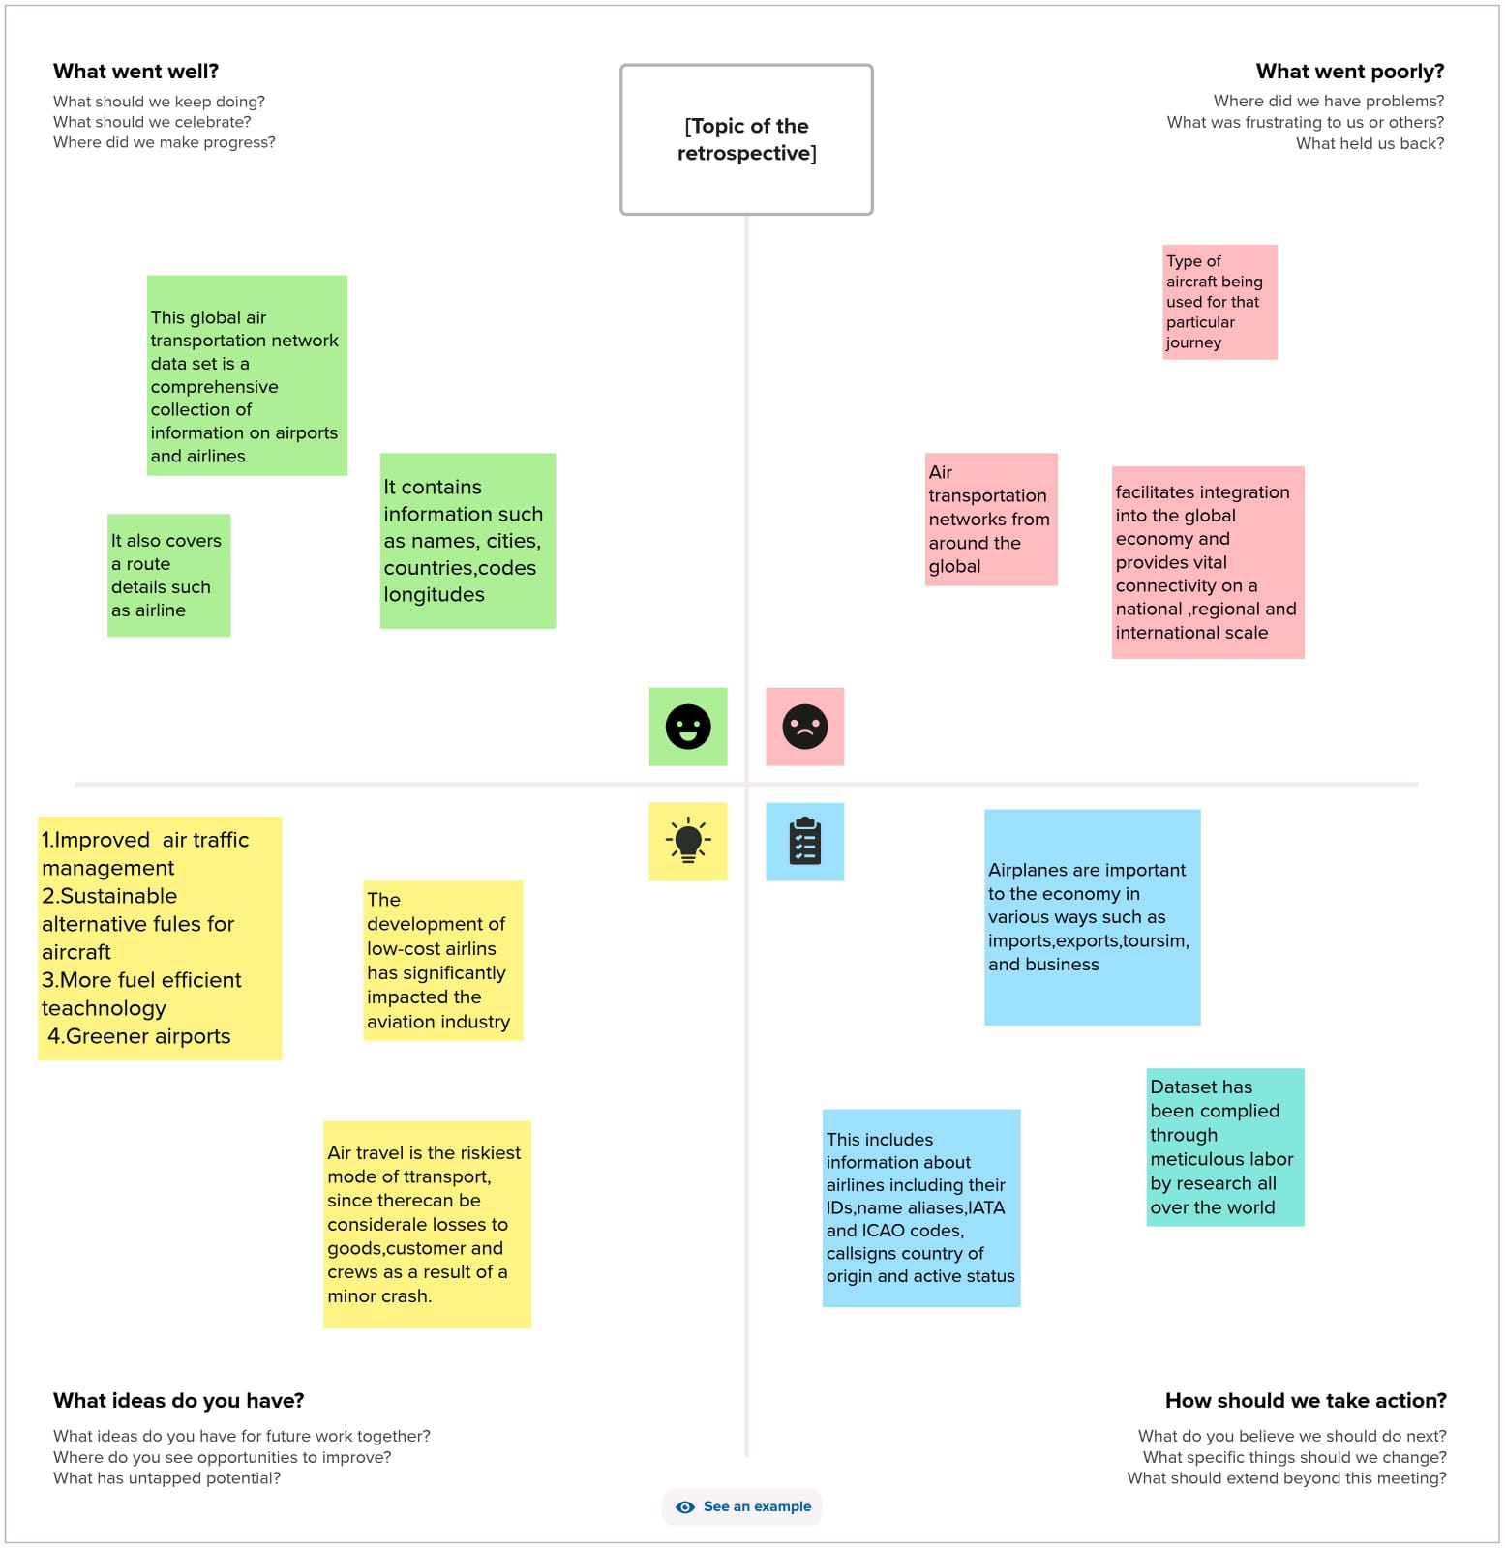

2.2.IDEATION AND BRAINSTORMING MAP:

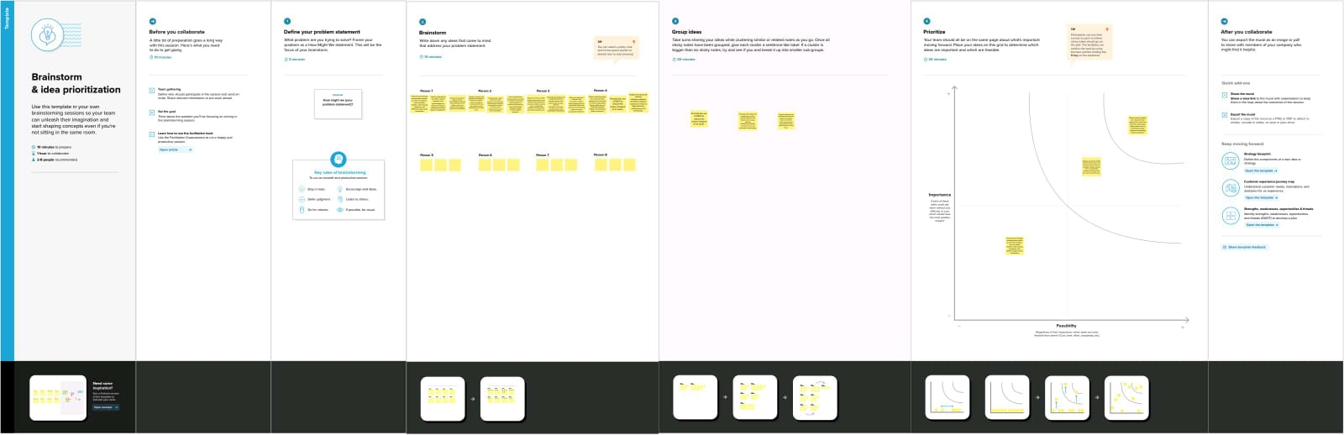

3.RESULT: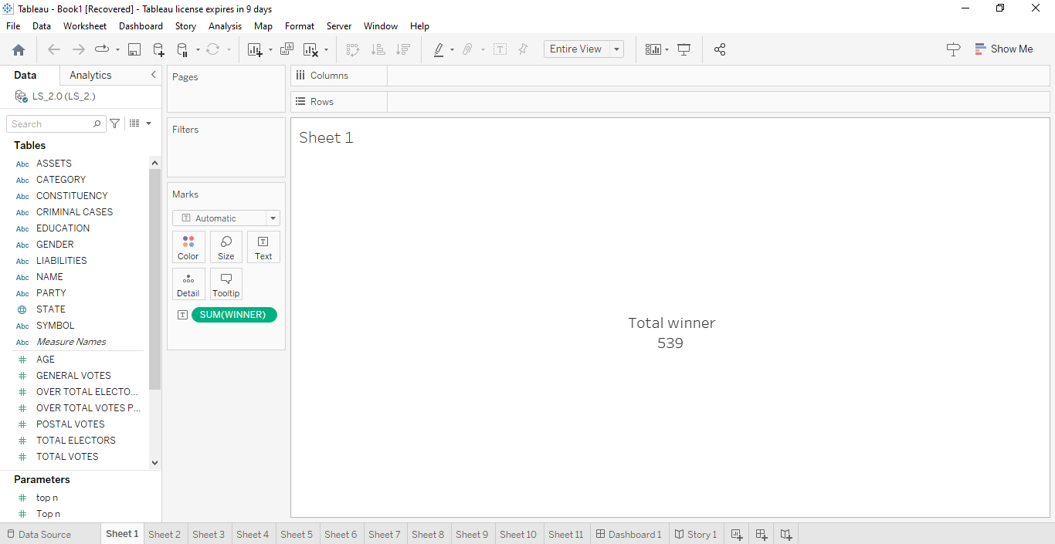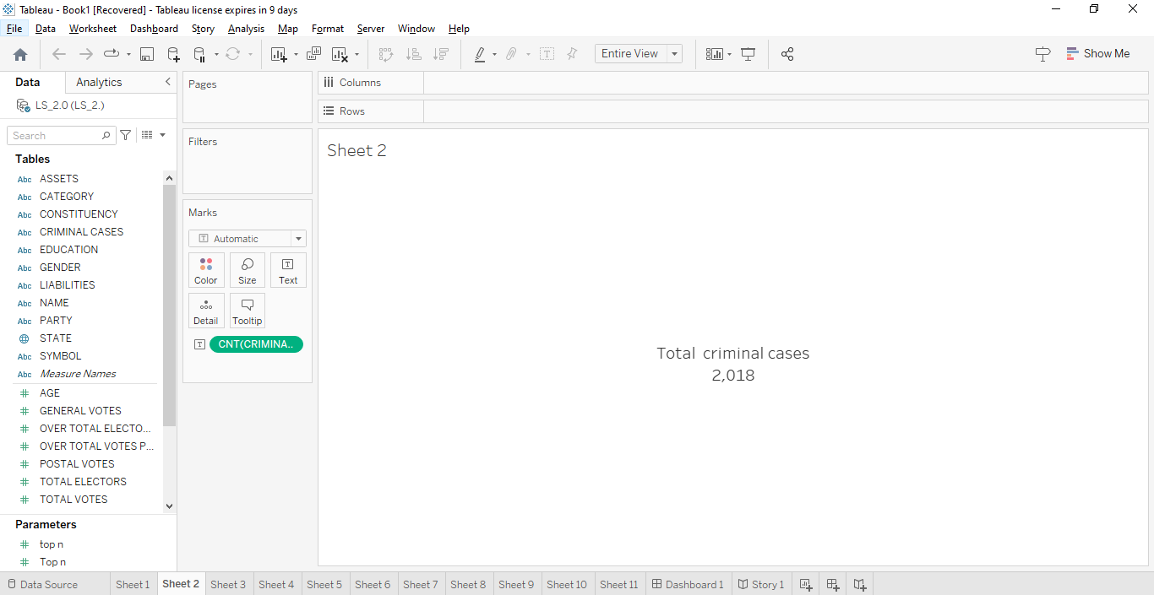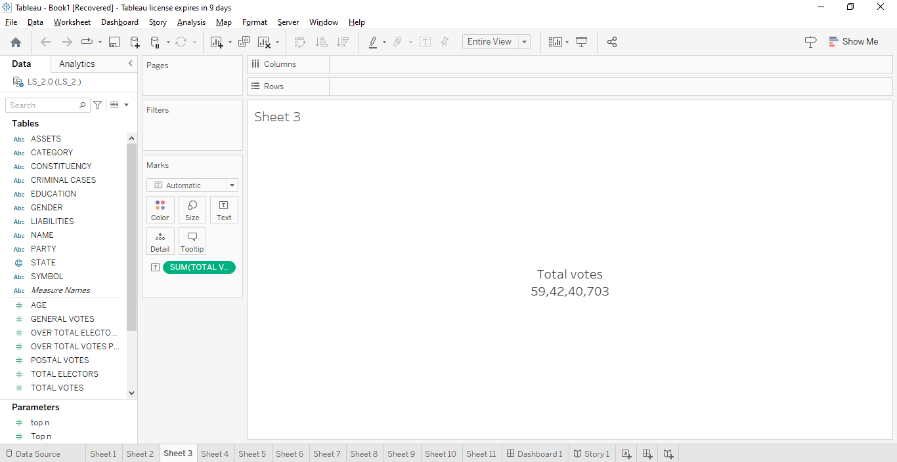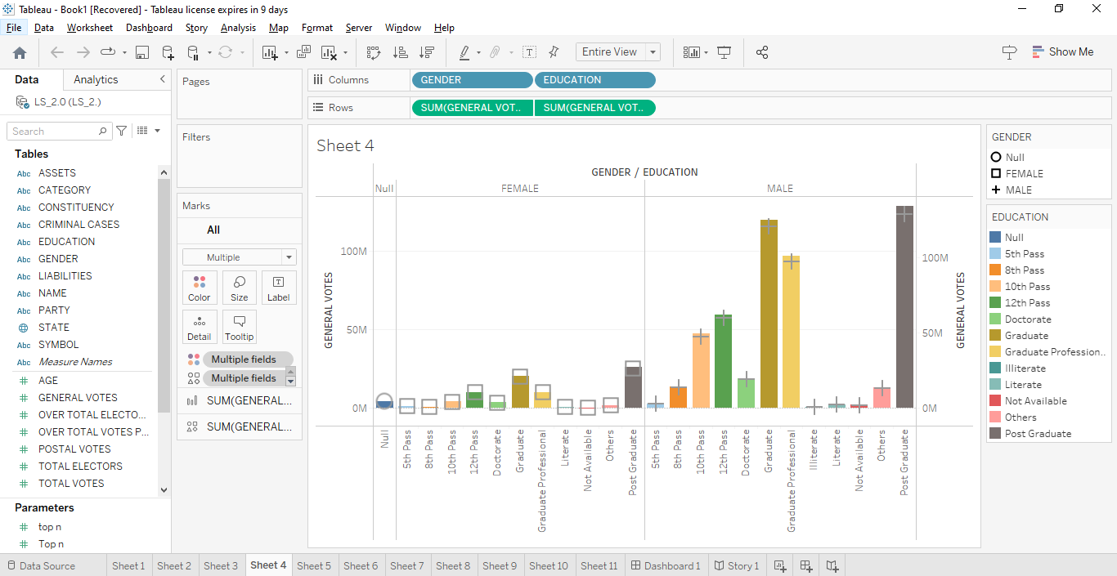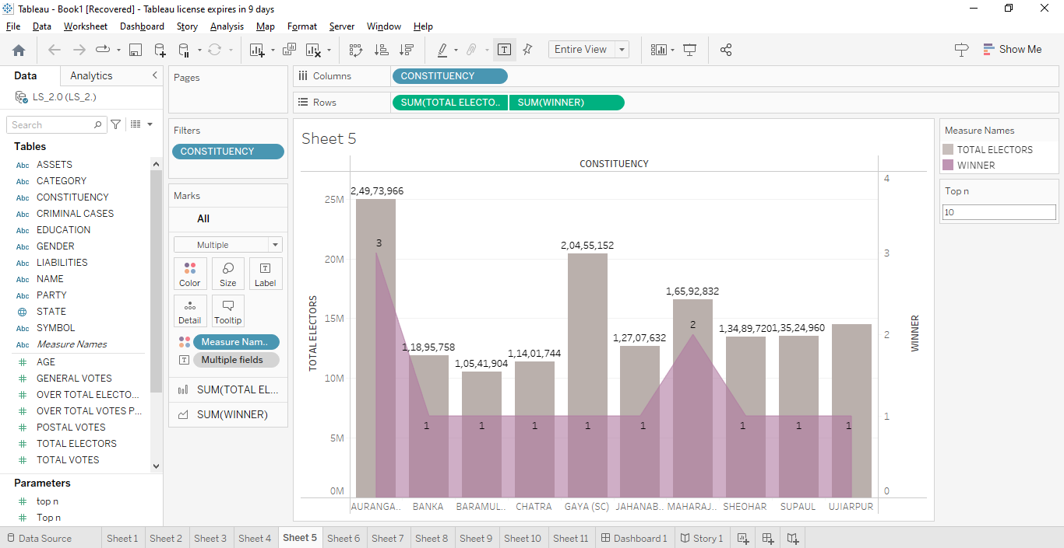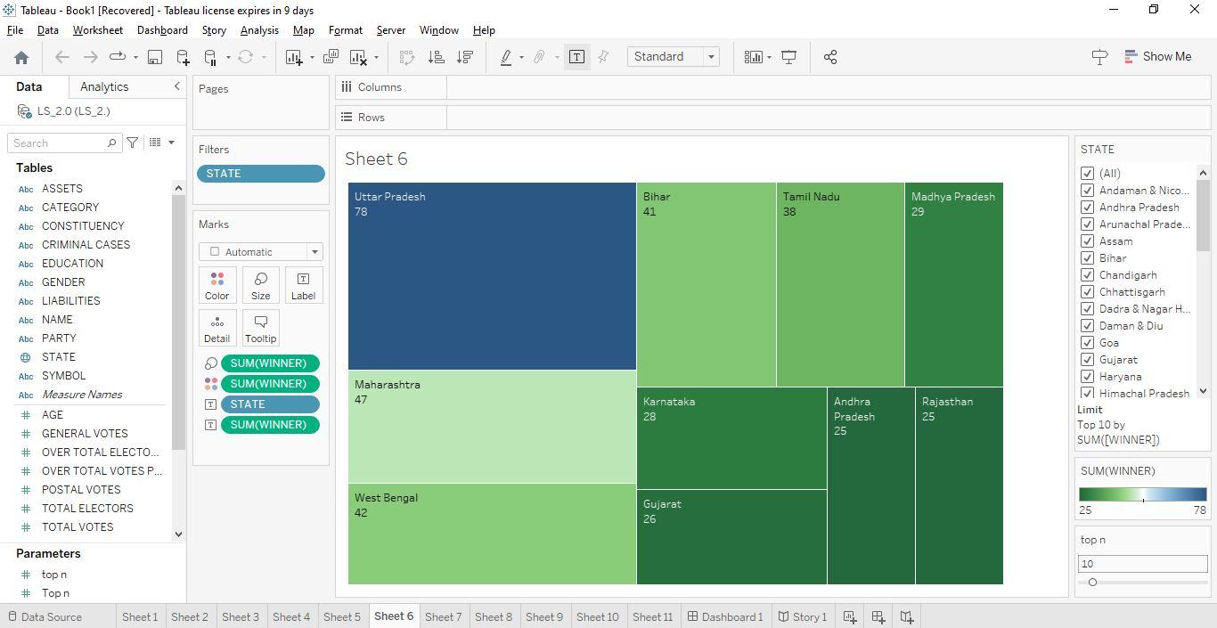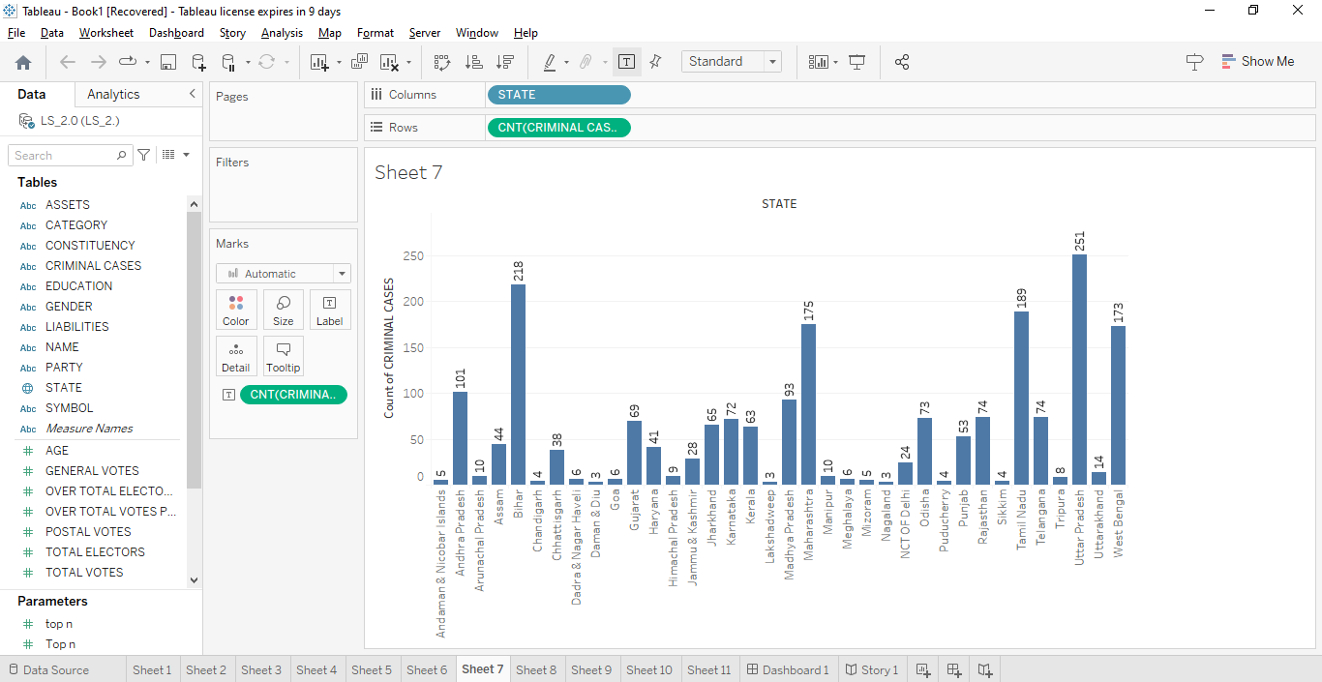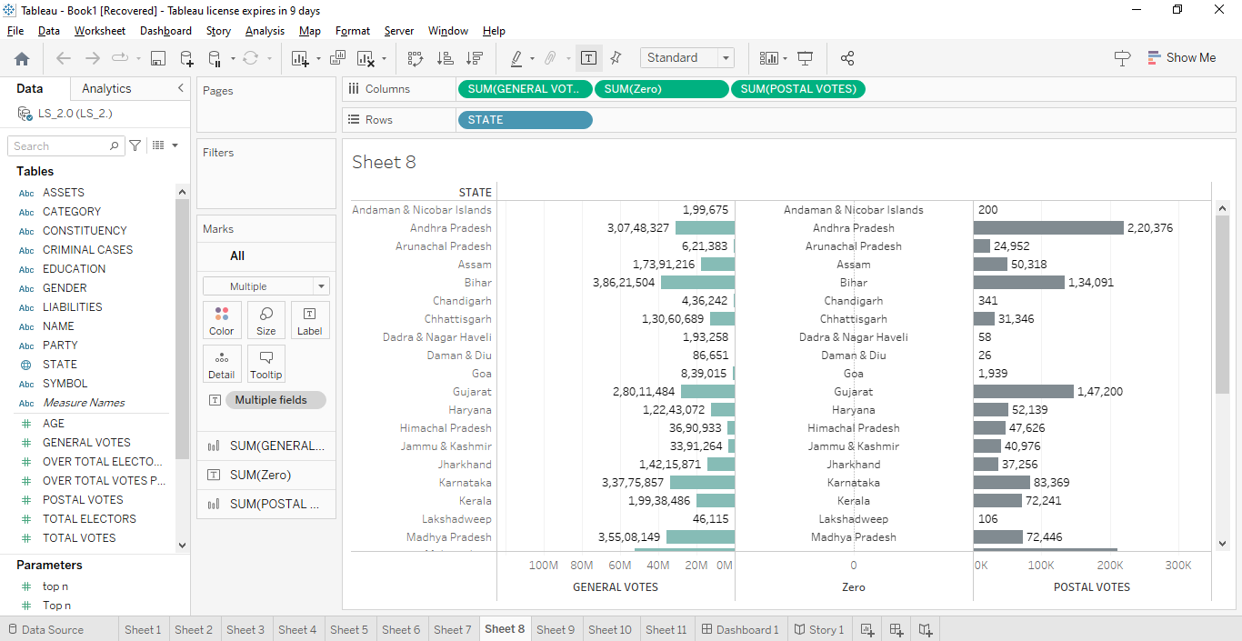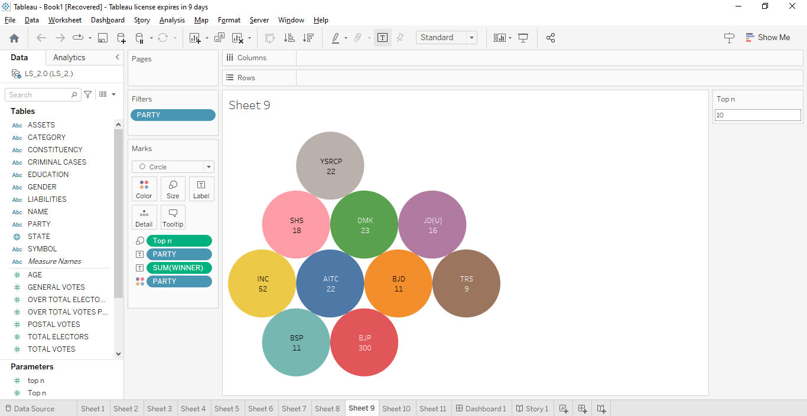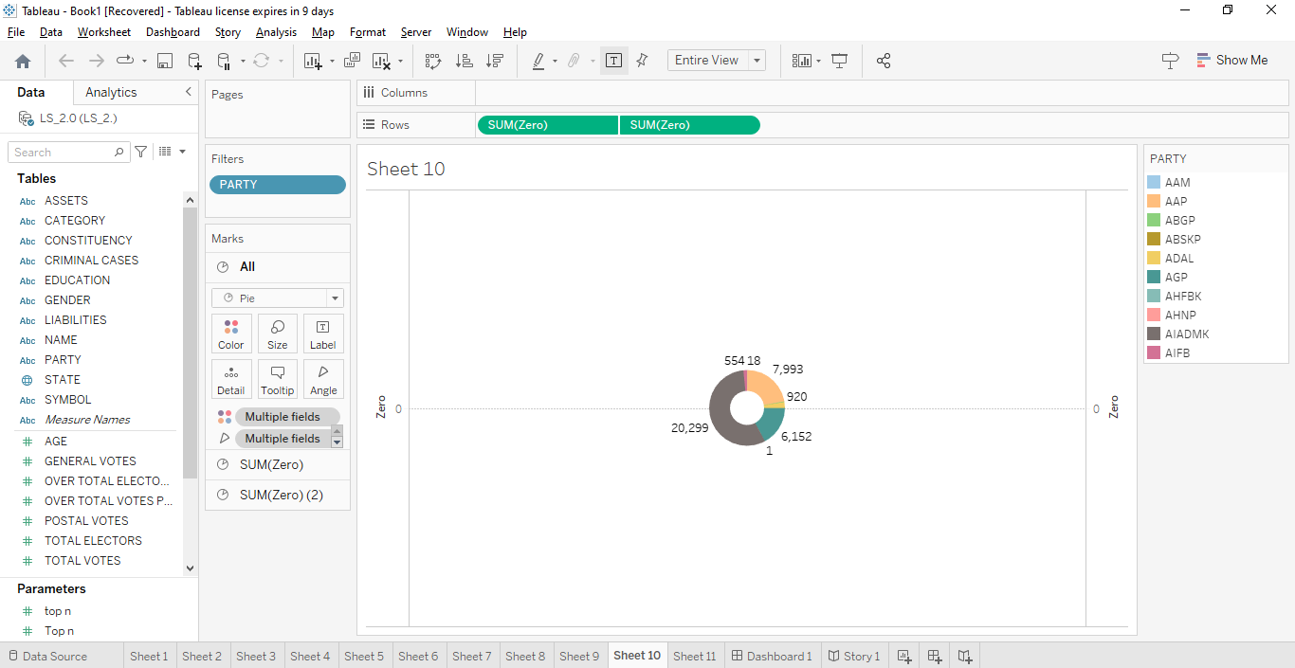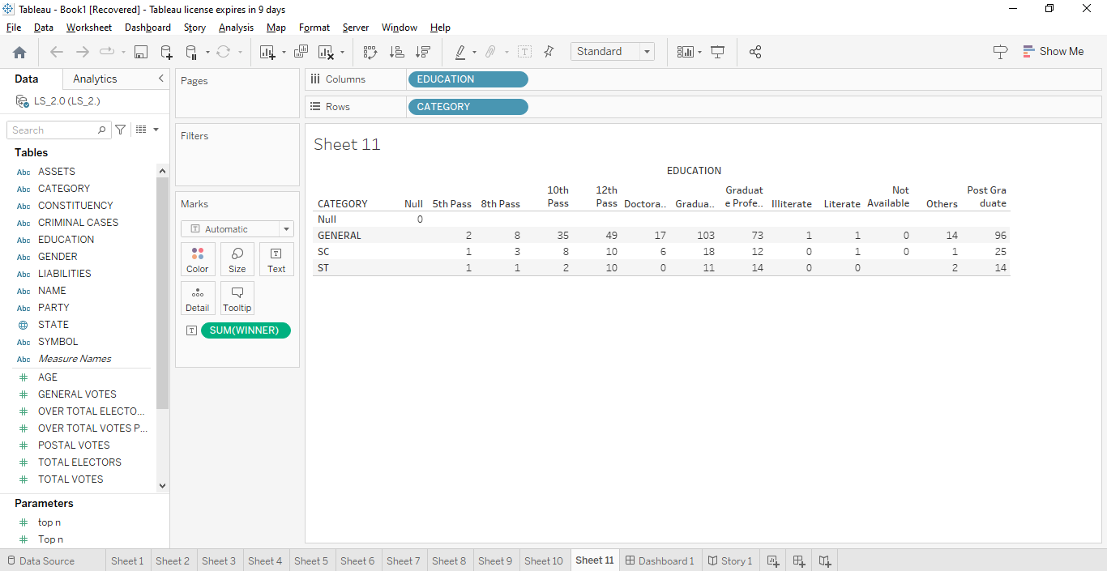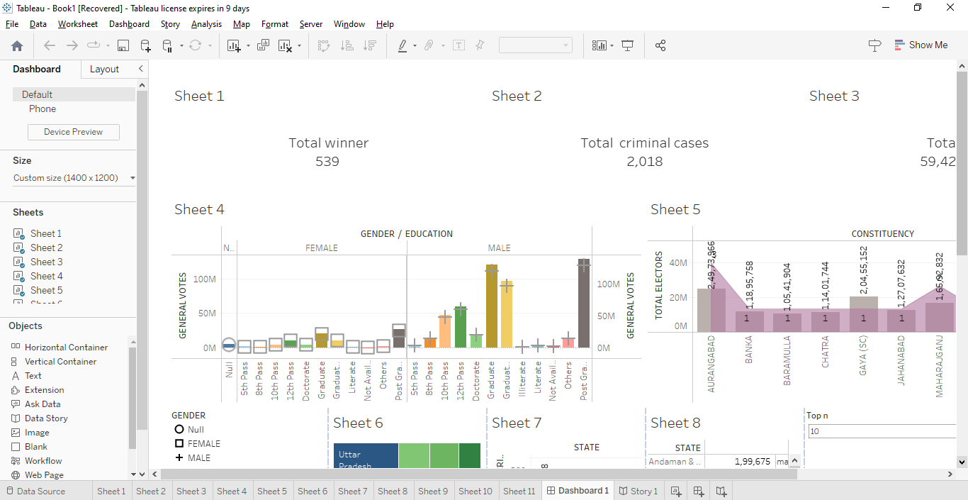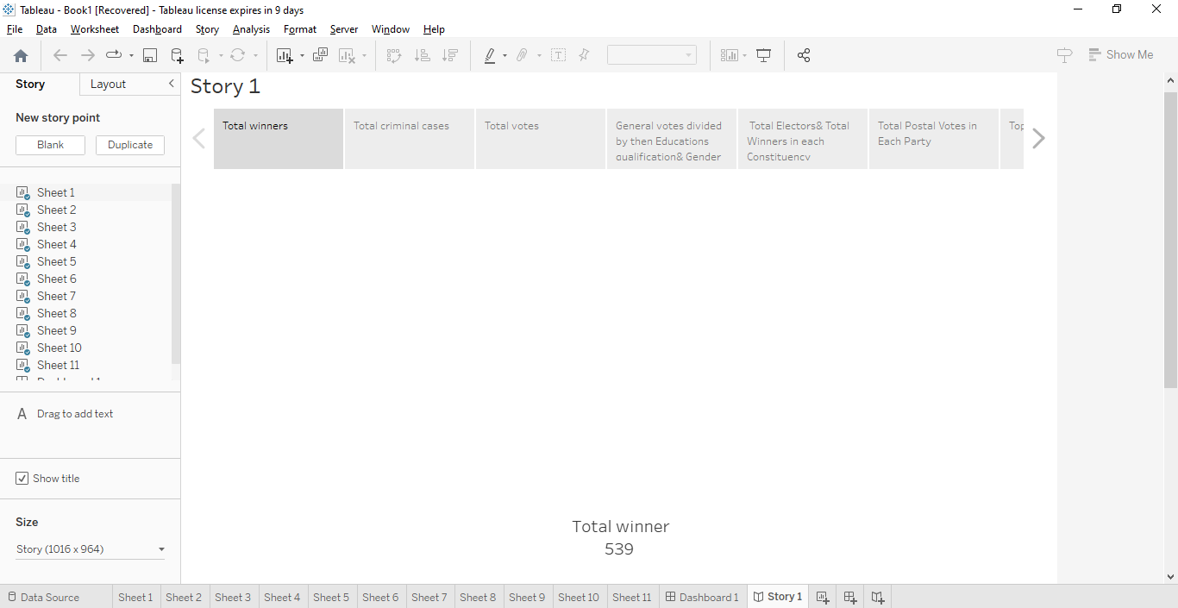

4.ADVANTAGES AND DISADVANTAGES

**Advantages:**

1. **Objective Insights:** Quantitative analysis provides objective and data-driven insights into the election, reducing the potential for bias in the research.
2. **Comprehensive Understanding:** A quantitative approach allows for the examination of a wide range of factors simultaneously, providing a more comprehensive understanding of the election.
3. **Replicability:** The research can be replicated or extended in future elections, allowing for the tracking of changes and trends in Indian politics over time.
4. **Statistical Significance:** With a large dataset, statistical analyses can identify patterns and correlations that might not be immediately evident through qualitative methods.
5. **Policy Guidance:** The research can offer actionable recommendations for electoral reforms and policies to strengthen Indian democracy.
6. **Public Awareness:** By presenting findings through data visualization and accessible reports, the research can raise public awareness and engagement in the political process.

**Disadvantages:**

1. **Data Availability:** Obtaining comprehensive and reliable data for such a massive election can be challenging, and data quality issues can impact the accuracy of the analysis.
2. **Overlooking Nuances:** Quantitative analysis may not capture the nuanced details of the campaign or the qualitative aspects of candidate performance.
3. **Limited Context:** The quantitative approach may not fully account for the local, regional, and cultural factors that influence election outcomes, which are often vital in Indian elections.
4. **Simplification:** Some complexities of Indian politics and voter behavior cannot be adequately captured through quantitative analysis, potentially oversimplifying the real-world situation.
5. **Resource-Intensive:** Conducting a thorough quantitative analysis can be resource-intensive, requiring advanced statistical tools, data processing, and substantial time and expertise.
6. **Inevitable Generalization:** Quantitative analysis inherently involves making generalizations from data, which might not always represent the unique circumstances of individual constituencies or candidates.
7. **Ethical Concerns:** Data privacy and ethical considerations must be addressed when collecting and analyzing data related to candidates and voters.
8. **Rigidity:** A purely quantitative approach may limit the ability to adapt to emerging themes or issues during the analysis process.

It's important to recognize that a well-rounded research approach often combines quantitative and qualitative methods to mitigate the disadvantages and enhance the advantages of both. This allows for a more holistic understanding of the election and the factors influencing it.

5.APPLICATION

1. **Policy Formulation and Reforms:** The findings of this analysis can inform policymakers and electoral commissions about the strengths and weaknesses of the electoral process. It can lead to evidence-based policy formulation and electoral reforms aimed at improving the democratic process in India.
2. **Candidate Selection:** Political parties can use the insights to make more informed decisions when selecting candidates for future elections. They can consider the qualifications and backgrounds of candidates who were successful in 2019.
3. **Campaign Strategy Optimization:** The research can help political parties refine their campaign strategies. By understanding what worked and what didn't in 2019, parties can allocate resources more effectively, whether in terms of social media engagement, rallies, or advertisements.
4. **Voter Education:** The findings can be used to educate voters about the factors they should consider when choosing a candidate. This can lead to more informed voting decisions and improved civic engagement.
5. **Academic Research:** The research can contribute to academic studies in political science, providing data and insights for future research projects and serving as a reference point for scholars.
6. **Media and Journalism:** Journalists can use the research findings to create informed, data-driven political reporting, fostering a better understanding of the intricacies of Indian democracy among the general public.

6.CONCLUSION

1. **Data-Driven Understanding**: The use of quantitative methods has provided a data-driven understanding of the election, allowing us to identify patterns, correlations, and trends that influenced candidate success and electoral outcomes.
2. **Candidate Diversity**: The research has highlighted the diversity of candidates who contested the 2019 Lok Sabha Election in terms of their backgrounds, qualifications, and political experience. This diversity is a testament to the vibrancy of Indian democracy.
3. **Campaign Strategies Matter**: The analysis has underlined the importance of effective campaign strategies, including resource allocation and social media engagement. Successful candidates and parties were often those who adapted to changing campaign dynamics.
4. **Electoral Outcomes and Factors**: The study has deepened our understanding of electoral outcomes by examining the influence of demographic composition, regional factors, and incumbency effects. These factors played a critical role in shaping the composition of the Lok Sabha.
5. **Policy Implications**: The research has important policy implications, offering recommendations for electoral reforms that can strengthen the Indian democratic process. These recommendations can guide policymakers in improving electoral procedures.
6. **Public Awareness and Engagement**: By presenting findings in accessible formats, this analysis has the potential to raise public awareness and engagement in the political process. Informed citizens are essential for a healthy democracy.
7. **Academic Contribution**: The research contributes to the academic body of knowledge in political science, providing a reference point for future scholars and researchers interested in Indian electoral politics.
8. **Historical Record**: This analysis serves as a valuable historical record of the 2019 Lok Sabha Election, preserving data and insights that can inform future studies and analyses.

In essence, "Political Juggernauts: A Quantitative Analysis of Candidates in the 2019 Lok Sabha Election" advances our understanding of the complexities of Indian democracy, provides a platform for data-driven policy recommendations, and contributes to the broader discussion on electoral politics in India. It highlights the importance of continuous research and analysis to strengthen democracy and ensure the effectiveness of political processes in the world's largest democracy.

7.FUTURE SCOPE

1. **Longitudinal Studies**: The research can serve as a foundation for longitudinal studies, tracking changes and trends in Indian electoral politics over multiple elections. This will provide insights into the evolution of Indian democracy.
2. **Sub-National Analysis**: Future research can delve into sub-national or state-level analyses to understand regional variations in candidate profiles, campaign strategies, and electoral outcomes. Each Indian state has its unique political dynamics.
3. **Comparative Studies**: Researchers can conduct comparative studies between the 2019 election and subsequent elections to assess the impact of policy changes, electoral reforms, and shifts in political discourse.
4. **Voter Behavior and Surveys**: Complementing quantitative data with qualitative research, such as voter surveys, can help in understanding the motivations and perceptions of voters in greater detail. This can provide valuable insights into voter behavior.
5. **Election Forecasts**: Building predictive models based on historical data can be a future scope, allowing for election forecasts that help political parties and analysts anticipate electoral outcomes.
6. **Local Governance Analysis**: Expanding the research to include data on local governance elections can shed light on the interplay between national and local politics in India's democratic system.
7. **Impact of Media and Social Media**: Investigating the influence of traditional media and social media on election outcomes and voter perceptions is a crucial area for future research, given the increasing role of digital platforms in politics.
8. **Women in Politics**: Focusing on the representation of women in Indian politics and their electoral experiences is a vital aspect of future research, particularly as gender diversity in political leadership is a growing concern.
9. **Impact of Demographic Changes**: The study of how changing demographics and urbanization affect electoral outcomes and candidate profiles can provide important insights.
10. **Youth Engagement**: Understanding the political engagement of the youth demographic and their preferences for candidates and parties is an area ripe for further exploration.
11. **Ethical and Privacy Considerations**: With increasing data collection in politics, there is a need to delve into the ethical and privacy considerations related to gathering and using political data.
12. **International Comparative Analysis**: Comparative research with elections in other democracies can provide a broader perspective on election dynamics and the unique features of Indian democracy.
13. **Election Monitoring and Transparency Initiatives**: Collaborating with election monitoring organizations and transparency initiatives to strengthen the electoral process through data-driven assessments and recommendations.
14. **Educational Initiatives**: Using research findings to develop educational programs and initiatives that promote civic education and political awareness among the youth and general public.
15. **Innovations in Data Analysis**: Leveraging advancements in data science and artificial intelligence to develop more sophisticated data analysis techniques for political research.

The quantitative analysis of the 2019 Lok Sabha Election has laid a solid foundation for ongoing research and activities, ensuring that insights into Indian democracy continue to evolve, contributing to the improvement of the electoral process and the health of Indian democracy.